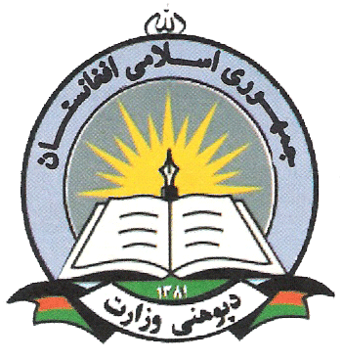

Islamic Republic of Afghanistan
Ministry of Education
Female Youth Employment Initiative (FYEI)
TOR: Communication and Reporting Officer

Post Title:
Communication and Reporting Officer
Unit: | Program
Type of Job: | Full Time
Duration: | 12 Months (Extendable)
Duty Station | Mazar-e-Sharif, Balkh Province, Travel to Kabul
Nationality Afghan
Gender: Male / Female

Project Background

The Female Youth Employment Initiative (FYEI) is a joint initiative between the World Bank and the Ministry of Education, Government of Afghanistan. A pilot project, the FYEI aims to address lacunae in the human capital attainments and paid employment opportunities for young women. The project consists two phases: phase 1 includes providing training to women and equipping them with skills that were deemed necessary for employment in the private and public sectors. And phase 2 includes placement of trainees in public and private enterprises for internship and employment. FYEI is one of several projects in low-income, conflict-affected countries that are part of the Adolescent Girls Initiative (AGI), launched by the World Bank in partnership with Nike Foundation. The pilot will be implemented in Balkh Province.

Main Responsibility of the Communication and Reporting Officer

The main responsibility of the Communication and Reporting officer will be efficient and effective implementation of communication strategies of the project. In undertaking the following responsibilities, the Communication and Reporting Officer will report to and work under the direct supervision of Project Director. Based on the developed strategy for communication, the communication and reporting officer will have to implement the whole communication and reporting activities of the FYEI.
Specific Responsibilities of Communication and Reporting Officer
More specifically, the work involves the following responsibilities:
- Implement the whole communication strategy developed for the project based on the guidelines and instruction that are set.
- Collect and synthesize data from the field, and draft the necessary reports.
- Prepare and develop all project related proposals, narrative reports, brochures, pamphlets, and action on specific components reports of the project whenever required.
- Will have to develop, revise and update the external and internal communication and reporting strategies.
- Collect and draft various success stories for the program from the field
- Keep record of Journalists, Media Houses, Civil Society Organizations, Printing Media and the translation service providers.
- Draft other ad hoc qualitative reports on specific project areas, as requested by the Project Director
- Review and edit reports from relevant departments, as required.
- Compile and edit the weekly reports from the provincial staff and related organizations..
- Update and maintain information on all donor and program reporting requirements.
- Ensure each concerned ministry, or relevant department heads are updated on these requirements and are provided project updates on regular basis
- Support Field Office during donors, media, other high level missions to the field, in collaboration with other project staff.
- Organize events and workshops as seen necessary for the project
- Liaise regularly with the Provincial staff to ensure the timely production and submission of quality reports across the components of the project
- Provided trainings to provincial staff whenever required and needed
- Undertake field visits, to all covered districts and training centers on regular basis.
- Collect the reports from the jurisdiction committees established in all targeted areas and prepare a comprehensive report on regular weekly basis
- Provide regular updates to local and national media regarding the progress, updates, achievements, and future plans of the project
- Maintain Archives for all FYEI reports
- Perform other activities as necessary and assigned by the project director
Education/Experience/Language/Skills

- To have B.A degree in one of the following subjects: Journalism, Public Relations, Communications or Social Sciences from recognized University
- To have at least 1-2 years of relevant professional experience in public relations, and media (including social media), Experience in dealing with different public institutions, local authorities, civil society, international and national cooperation agencies
- To have hands on experience in computer programs (Word, Excel, Power Point, Photoshop ), other multimedia software, internet and e-mail skills
- Excellent communication skills in English, Pashto and Dari languages
- Excellent writing, reading and speaking skills of English, Dari and Pashto languages
- Strong typing skills in English and local languages
- Ability to work collaboratively with colleagues to achieve the organizational goals
- Ability to translate various documents in local languages
- Ability to work in multi-cultural environment

